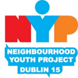

Blakestown and Mountview
neighbourhood Youth Project CLG

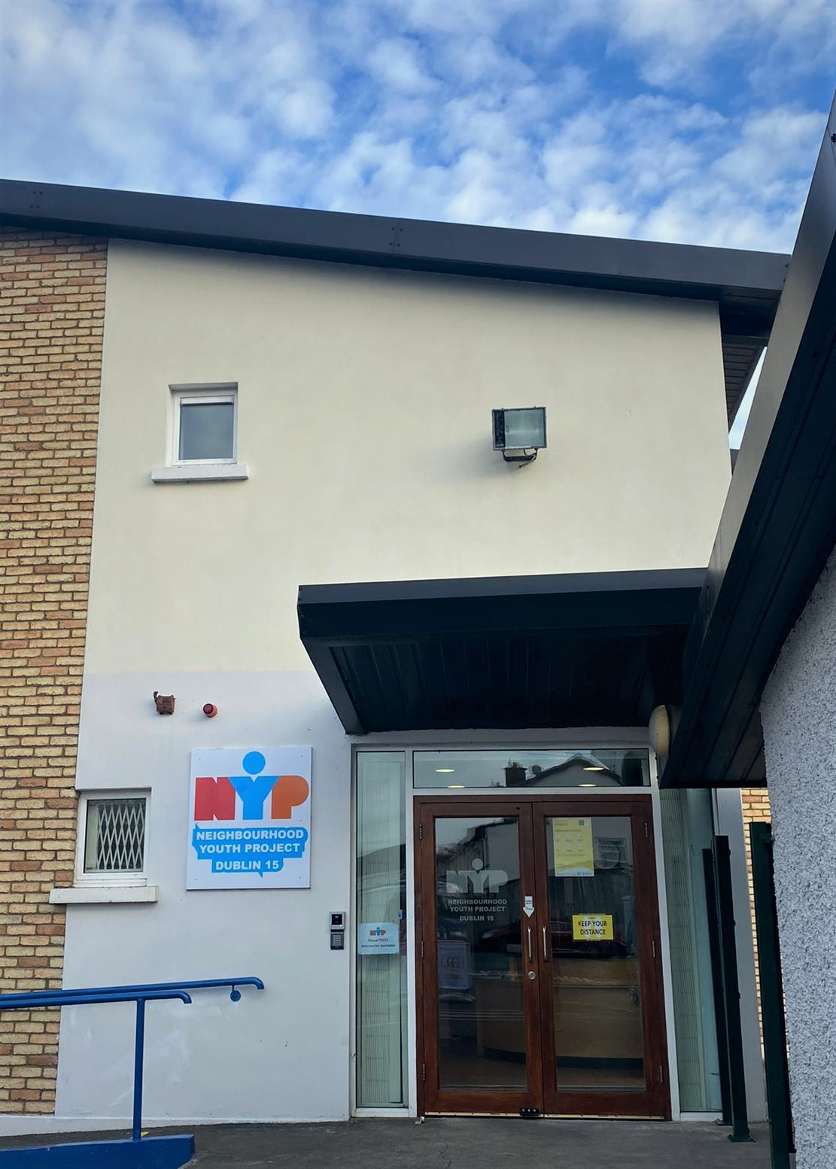
BACKGROUND OF NYP
Blakestown and Mountview Neighbourhood Youth Project (NYP) was established in 1993, following an intensive agency/community effort responding to local needs to support a targeted youth and family focused project. The Eastern Health Board, Dublin City Council, An Garda Siochana, Blanchardstown Area Partnership, local schools, Youth Services and Community Representatives worked together to source funding and premises and subsequently became members of the Limited company which was then established to provide a local service to at risk 9-13 year olds and their families.

The Eastern Health Board core funded the Project and provided significant funding towards a refurbishment of the premises at Shelerin Road (adjacent to Mountview Health Centre) was completed in 1994 and opened by Mary Robinson in 1995.
Funding for a new additional building on the grounds was received from a number of funders including the Health Service Executive, Fingal County Council, Irish Famine Trust, Young People’s Facilities and Services Fund, Equal Opportunities for Child Care, WEB Garda Diversion Project, and Clann Credo. In 2005 the building was opened by An Taoiseach Mr. Bertie Ahern.

NYP Supports and Service Objectives

Blakestown & Mountview NYP is a specialised community-based youth project offering free, supportive and inclusive services to the local community of Dublin 15. While much has changed over the years our mission has remained the same; working with vulnerable 8-14 year olds, and their families, through evolving, innovative & creative services and interventions. Today the project provides targeted individual and group developmental programmes and supports; nurturing and empowering all who engage to reach their full potential. All NYP supports, services and interventions are developed and offered in line with the National outcomes as outlined and prescribed in the national guidance ‘Better Outcomes; Brighter Futures’.
NYP is a referral based service. This allows us to use our internal processes to assess and identify the needs of young people and follow up with the most appropriate supports and interventions. Children and families can be referred for supports by schools, other agencies and health services. Referrals from parents are also welcome. Our simple referral form asks potential referrers to (after seeking permission to share the contact information) inform us of a young person or family that you feel could use support. Once received, we take it from there, make contact with parents in a timely manner and will work to engage the family.
NYP is dedicated to the provision of quality project work and committed to continuous improvement and best practice in child and family education and development. Our work focuses on promoting equality and inclusiveness and a non-judgemental, child centred and family support approach. NYP recognises the rights of young people and holds as central their active and voluntary participation in all aspects of the work. NYP is child and youth person-centred organisation children can influence decisions about their own lives and wellbeing and inform the service delivery. Levels of engagement are closely monitored and supported by our processes and systems in every way to encourage active participation from all stakeholders.
We are fortunate to have a team of highly trained and professionally qualified staff, dedicated to working with young people to bring about change and growth, which brings a great and diverse experience and knowledge to our programmes across a range of roles and areas of work within the project. Programme planning is led by the referral needs of young people and services offered are ever-evolving in response. The core aspects of our work come under these areas:
Project Work – focuses on fun, inclusion, relationship building, collaborating with young people and identifying their needs, we offer groups to young people to support and enhance their personal, social and emotional development through active participation. Interventions have traditionally happened within the centre itself and in school settings, forging links that further support young people. Afterschool groups / project interventions for children and young people aged from 8 and 14 years provide a variety of needs based programmes. Groups take place afterschool from Monday to Friday afternoon and Tuesday to Thursday evenings.
School holiday projects and supports form a big part of this work; offering alternative activities, supports, and programmes during school holiday times, when there is less structure and support readily available and risk and vulnerability can increase, to encourage the continuous engagement of young people and families and increase accessibility of services.
Family Support – using strength based approaches we work collaboratively with families to enhance coping and resilience and to bring about better outcomes for all. Through formal evidence based programmes and more informal interventions supports are available for issues that arising for families including parenting, parent and child relationships, sibling support programme, housing and drug and alcohol issues. Supports can be tailored to each family and respond to them in the most suitable way, be it in the home or the centre, individually or in a group setting.
Ongoing support of parents/ guardians/ carers of referred children and one to one support is crucial to our work. Family work provides a holistic approach to family crisis management. The family support team works in partnership with families to promote their own coping and resilience skills from strengths based and needs led perspective. We encourage positive attitudes to mental health and the empowerment of parents to give them the confidence to manage their own day to day challenges through the development and facilitating formal and informal parenting interventions. NYP offers a variety of practical supports based on the family’s needs including: educational support measures, arranging attendance at adolescent health services and access to relevant external services. Parents support groups raise awareness of issues arising and supports available, offers peer based support parents of referred and early years children.
Life skills – provides more targeted interventions to young people and their families to develop and flourish in terms of specific and relevant needs, such as relationships and sexual educational education, health and nutrition education and promotion and behaviour management. Our life skills aspect brings a strong emphasis on activity and health to the programmes in the project.
Education Support – a crucial aspect of our project is supporting and empowering the education of young people with interventions to support transitions and to offer additional time and space with our teachers to work on areas of difficulty. We work both in the school setting and after school and aim to include organisational and social skills needed to do well in school alongside academic support in our work.
Community Support – as a well established part of the community we take our role in its progress and development seriously and we have been active in empowering the community to address and overcome arising issues. Community Development work in NYP includes representation on local community groups, working on community based projects and the delivery of interventions responding to issues arising within the community that impact on the lives of children. It is an area of our work that requires flexibility and innovation in responding to and exploring topics such as addiction prevention, homelessness, bereavement support. We enjoy bringing people together from the wider community to work on environmental issues, playing a role in information sharing and advocacy, and facilitating development and growth across the community.
NYP Early Years – offers inclusive educational services for children and their families by providing ECCE pre-school places, part-time and session-based CCS places as well as school aged childcare and summer programmes.

ACTIVITY DETAILS

After schools groups:
Structured groups for primary school aged young people, systematically themed to ensure the exploration and promotion of and the understanding and integration into daily lives of:
- mental health awareness and support, positivity and mindset
- local, community & ecological issues
- healthy lifestyle needs
- sports & physical activity needs
- self-care; relaxation & personal development
- educational support
As standard there are 10 after school groups per week; yielding up to 3,582 contacts in 2021.

Evening Groups for 1st Year Students:
Offering a supportive social setting for young people to explore and work on issues relevant to their age group and transition to second level education across a thematic spectrum including:
- mental health awareness and support, positivity & mindset
- local, community & ecological issues
- healthy lifestyle needs
- sports & physical activity needs
- self-care, relaxation & personal development
- educational support
These groups run 3 evenings per week (Tuesday to Thursday); yielding up to 1194 contacts in 2021

In-school support for 1st year students:
Offering a supportive space for young people amid their school day 4 days per week.
Yielding up to 2,048 contacts during in 2021

School Holiday Projects:
Offering more intensive supports in times when the structure of school has stopped
Easter 2021 1 week @ 8 sessions per week @ 12 young people per session
Summer 2021 7 weeks @ 8 sessions per week @ 12+ young people per session
Halloween 2021 1 week @ 2 sessions per day @ 12+ young people per session

Educational Support:
After school support & in school education
Intensive supports in 4 schools groups
Supporting parents with home learning
Resources to children and parents
Transition groups for 6th class to 1st year with referred children
Tailored brief interventions

Parent Supports & Community Interventions:
Parenting programmes
Community breakfast
Addiction prevention education
Home learning workshops
Engagement with Child & Family Support Network
Parent Support Networks
Addiction prevention education
Tailored Brief Interventions
Outreach Work

Covid-19 Response

World events in 2020 and 2021 forced significant changes in NYP practices and highlighted very clearly the benefit and vital nature of face-to-face interactions in working with children, young people and families. We learned quickly that we needed to adapt in order to continue with our objectives and mission in supporting families, more pertinent as people became isolated in fear and unfamiliar circumstances. Staff were equipped to work remotely and we made the unprecedented move to online work to sustain supports for vulnerable people in the community during times of lockdown offering, at times, a life line to outside world for many. We very successfully established communication structures with parents / guardians and, having seen the value and benefit of it, continued the practice after returning to face to face work. Our planned supports included:
- Weekly check in – parental support by phone made available to every referred parent/ guardian
- Online groups (zoom) for young people, including postage of resources needed for groups
- Availability of education support staff in home-schooling
- Outreach work through food hampers, resource activity packs for children
- Online (Zoom) workshops for Parents / Guardians
- Identification and support for families with a technological deficit and so limited to enable access to supports and education
The learnings of the time have left the organisation experienced and prepared to adapt to situations beyond our control; remaining focused on the task and providing the best quality service to those we support in a meaningful and planned way.

GRANTS

In 2021 NYP secured a number of small grants to support the continuance and development of our services to young people and families in the D15 community. Fingal County Council supports our summer programme of activities over 7 weeks. Fingal Chamber of commerce supported the installation of our new Computer Hub. The National Lottery made a contribution toward the development of a safe outdoors area for children to allow NYP to comply with Covid Public Health safety regulations. Fingal County Council helped to replace resources and programme materials lost following storm damage in January 2021. The Sports Capital Programme Grant was achieved in 2021 to upgrade existing sports equipment and the purchase of new items.

EXPECTED OUTPUTS OF SERVICES

NYP aims to reduce social barriers, assisting families in overcoming situations of isolation and in turn offer parents and children valuable opportunities to develop an appreciation of themselves as individuals and as members of the wider community. We prioritise a provision of services which are easily accessible and delivered to the highest quality, ensuring positive experiences for all involved in NYP:
- Support of educational development of 8-14 year olds to achieve their full potential in all areas of learning and development.
- To promote participation in activities which focus on positive physical and mental wellbeing growth and development.
- Parent support networks and interventions to provide parents and family members ongoing support in the important task of parenting and feel more confident, informed and able e.g. parenting programmes.
- Children are safe and protected from harm through prevention, early interventions and effective crisis intervention strategies e.g. rapid response to referrals.
- Drug Education prevention education to raise awareness and responses to drug use e.g. cannabis, alcohol use in teens and preteens in D15 e.g. modules on substance misuse with pre-teens.
- Interactive group programmes to develop skills in response to identified needs e.g. cyber safety/gaming safety. e.g. social media safety workshops.
- Working with CFSN to practically identify and support the needs of children and families in the D15 community to ensure that those who are most in need receive the supports they need when they need them e.g. working collaboratively within D15 community.
- Life Skills development to support children through a number of intensive interventions designed in response on their expressed individual needs.

