Upcoming Free TRIPLE P: Parenting Supports
Does your child feel anxious at times?
We are hosting the Triple P Fear-Less Seminar
The Fearless group will be starting Tuesday 21st of June from 10-12 in NYP
Fear-Less is a parenting seminar aims to teach parents strategies that will help reduce anxiety in children aged 6-12 years old.
The Seminar will cover the Following topics:
• How does anxiety work?
• Understanding anxiety
• Parents as models
• Being an emotion coach
• Managing children’s anxious behavior
• Constructive coping and problem solving.

If you are interested please contact Moira on 0860355472.
(We will need your name, address and an email address).
Please feel free to contact us if you have any questions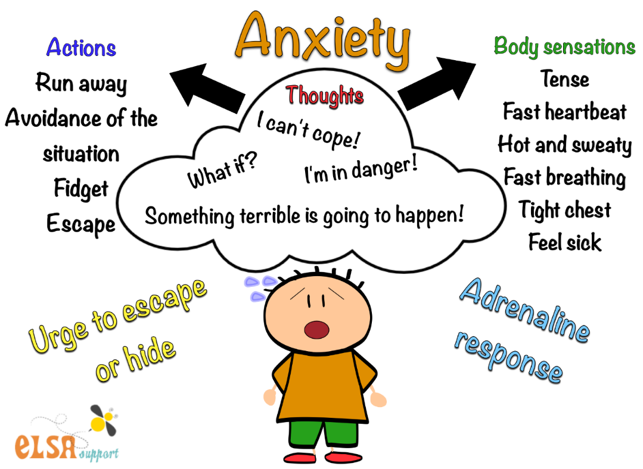

NYP (Neighbourhood Youth Project), Shelerin Road, Clonsilla, Dublin 15. Phone 01 8205253

